- Another month, another overshoot for UK services inflation. Financial markets reacted hawkishly to this week's data. But given it was largely due to a spike in hotel prices – possibly connected to Taylor Swift's tour – there's a good chance it will soon unwind. Elsewhere, pay growth continued to cool, while the data on labour market tightness was mixed.
- This leaves the Monetary Policy Committee with a dilemma. The data shouldn't unnerve the doves – after all, they've said they are placing less weight on these backward-looking measures. But the market reaction might. And the silence from the doves since June hardly suggests an urgent need to cut. So we're leaning towards the first rate cut being delayed until September.
In recent weeks, financial market pricing had steadily moved behind an August rate cut, falling into line with our long-held view. This week promised to provide the sternest test of that call, with the final set of inflation and labour market data to be published before the Monetary Policy Committee meeting. Though the data put a dampener on markets' expectations, we think the picture is more nuanced and that August's decision is on a knife-edge.
Wednesday's inflation release caused the disquiet, with stronger-than-expected services inflation keeping the headline rate at 2%. Markets were unnerved because of the MPC's long-running focus on services inflation as an indicator of inflation persistence, with June's outturn coming in 0.6ppts higher than the forecast made by Bank of England staff in May's Monetary Policy Report (Chart 1).
But the implications are less clear cut than the market reaction would indicate. For starters, April and May's outturns were already 0.4ppts higher than the BoE staff forecast. June's MPC minutes suggested the dovish camp were relaxed about this development, attributing it to a larger-than-expected impact of the annual uprating of index-linked contracts and regulated prices. Given these prices change once a year, that overshoot is effectively now baked in until next spring. So it's only the extra 0.2ppts in June that's "news".
Chart 1: Services inflation has continued to overshoot BoE staff forecasts in recent months
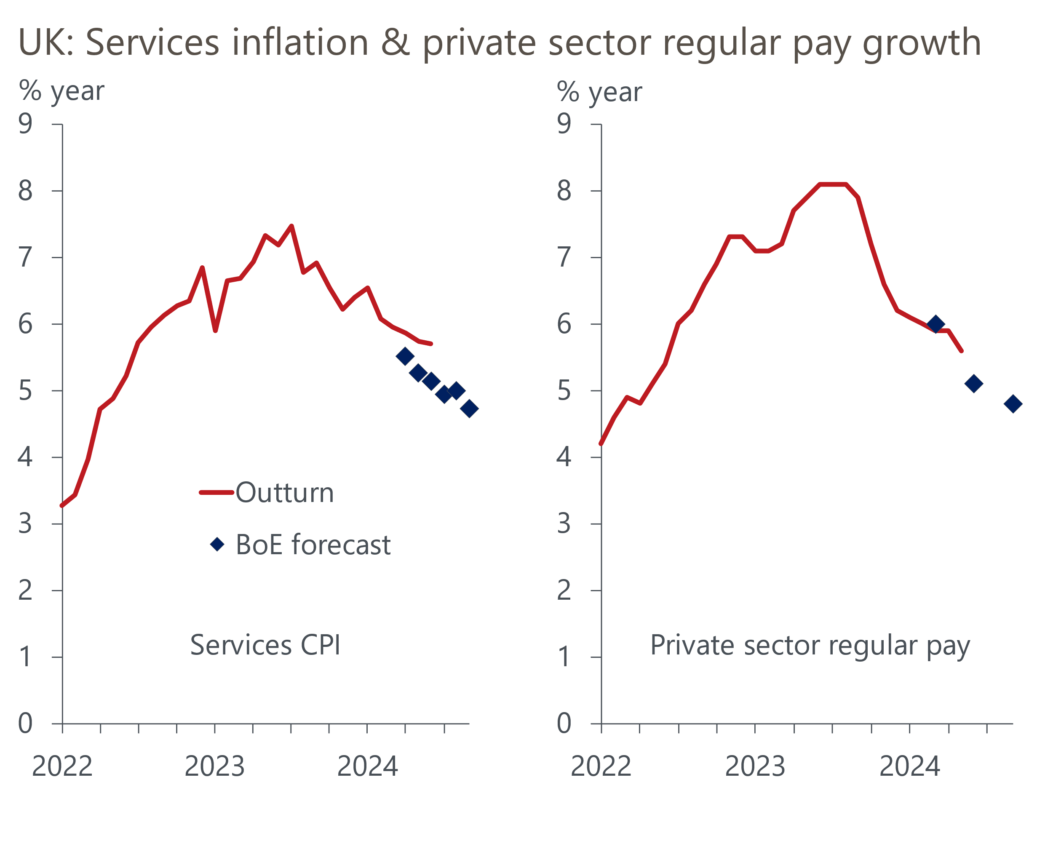
Sources: Haver Analytics, Bank of England Monetary Policy Report, May 2024

A deep dive into the data suggests here too the picture is more nuanced. The Office for National Statistics publishes the individual price quotes that feed into the CPI, and this dataset shows exceptionally high month-on-month increases in prices for two hotels between May and June (Chart 2). It may not be a coincidence that these hotels were in the North West and Wales and that the date that most of the price quotes were collected was close to the date that Taylor Swift's Eras tour rolled into Liverpool.
Chart 2: Most of June's overshoot can be traced back to very large price rises in two hotels
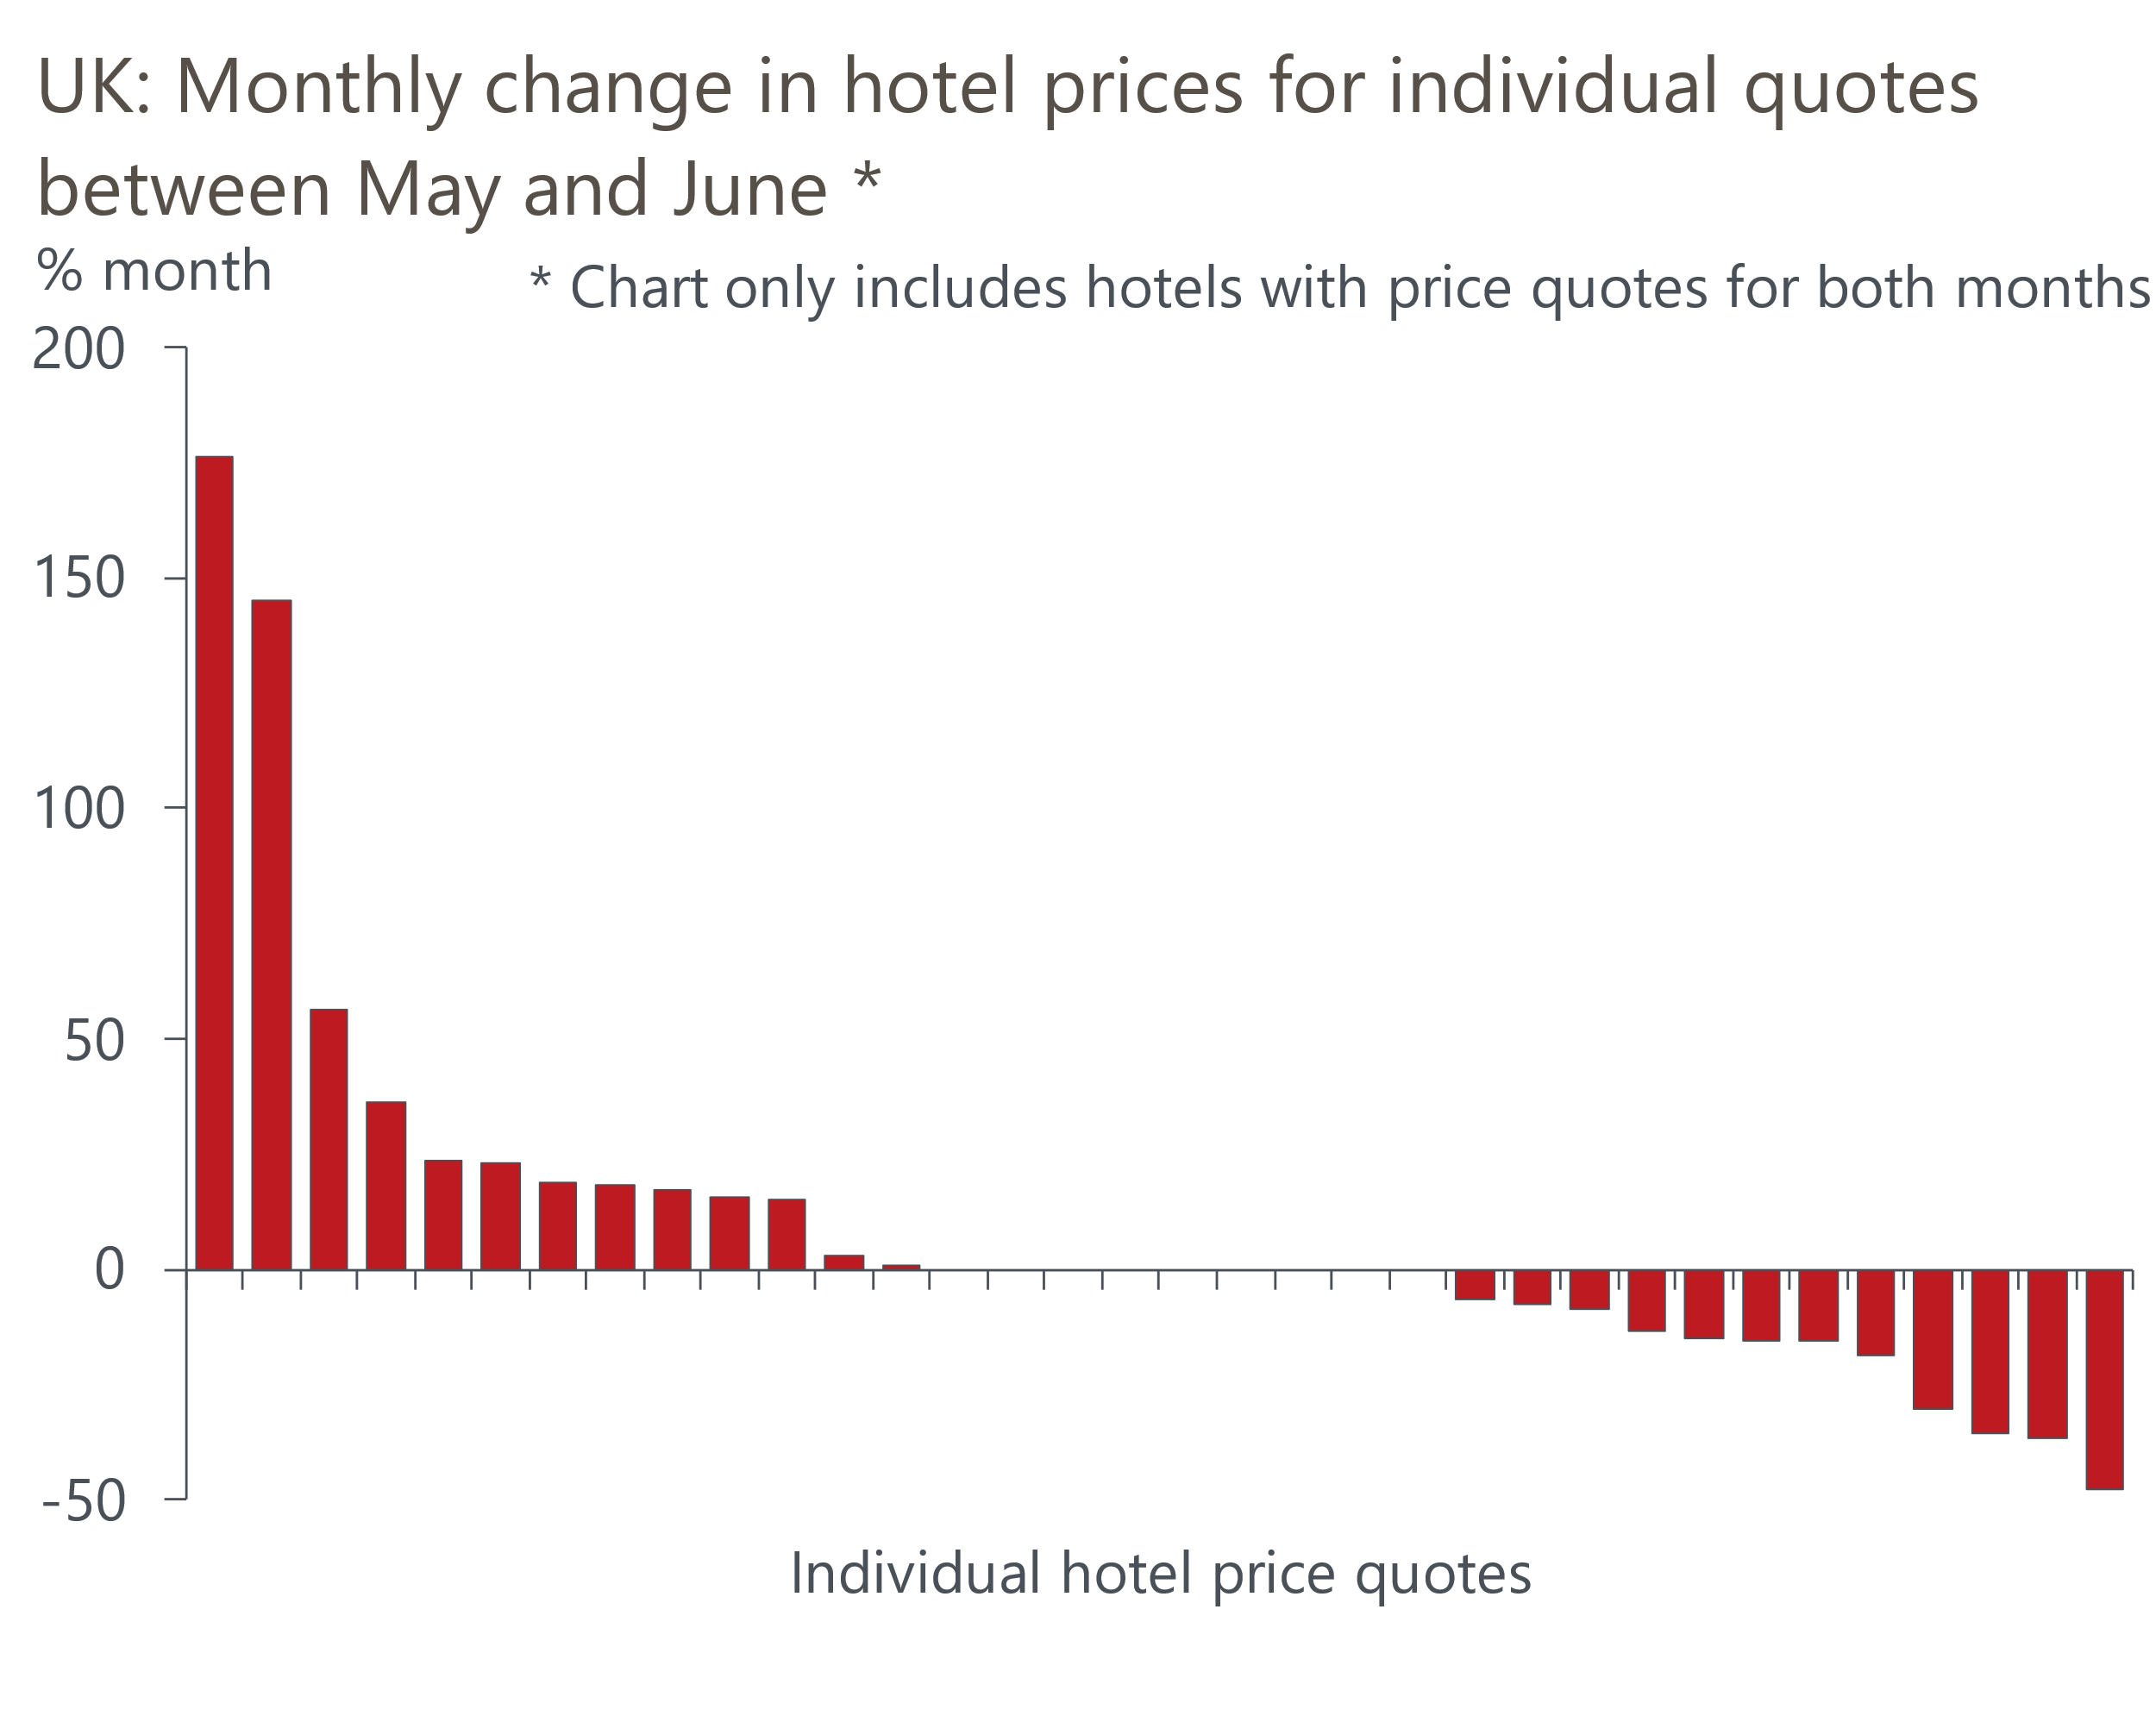
Source: Oxford Economics calculations using data from ONS
This caused prices in the accommodation services category to spike up in June. We calculate that had prices in this category risen by the average month-on-month change seen over the past 25 years, services inflation would have been 0.2ppts lower in June. So most of the overshoot can be attributed to noise and will likely unwind over the coming months, particularly if it is Swift-related.
There was better news for the MPC on wages. Headline (three-month average of the annual rate) private sector regular pay growth dropped to a 23-month low of 5.6% in May. HMRC payroll data suggests pay growth cooled further in June, with the slowdown in both series exaggerated by strong base effects. But the 5.1% forecast for Q2 made by Bank of England staff in May's Monetary Policy Report still looks sound (Chart 1).
The picture was more mixed in terms of broader labour market conditions. Vacancies continued to fall, but HMRC's count of payrolled employees rose in both April and May. The ONS also announced that the introduction of the transformed Labour Force Survey will be delayed by six months. So the wait for reliable data on labour market quantities goes on, just at the time when it's needed most.
The week's developments leave the MPC in a real quandary. In June, a group, that we think would be big enough to form a majority, signalled they were moving closer to voting for a cut. That they were clear they were less concerned about backward-looking measures of inflation persistence, such as services inflation, and had already shown willingness to overlook two large overshoots, suggests that this week's data shouldn't be a deal breaker for them.
But while the data itself might not be enough to change their minds, the market reaction might be. On Thursday, markets pricing implied the probability of an August cut was below 40%. Since November 2021, the MPC hasn't gone against the market consensus, and it’s not clear that the doves think the situation is sufficiently urgent that they should do so now. That none of those who we think might switch to voting for a cut have provided any on-the-record commentary since the June meeting suggests a lack of urgency on their part. That could well change – an intervention from the Governor next week would almost certainly be enough to get markets onside. But currently there are no speeches planned before purdah restrictions begin. So we are leaning towards the first cut being delayed until September, with the doves using August's meeting to reiterate the message that they are close to switching.

The week ahead
Next week's only major release is the flash S&P Global survey for July. June's surveys saw the PMIs slip back in both sectors. But the results can be very volatile from month-to-month and we think there's a good chance that both PMIs will rebound in July, not least because the commentary accompanying June's survey made much of election-related uncertainty. We expect the manufacturing PMI to rise to 51.2 and the services balance to reach 52.5. This would mean that the composite PMI recovers to 52.7.
Table 1: Week ahead calendar
Date | Events | Period | Measure | Unit | Previous | Forecast
Jul 24 | S&P Global manufacturing | Jul | PMI | % bal | 50.9 | 51.2
Jul 24 | S&P Global services | Jul | PMI | % bal | 52.1 | 52.5
Jul 24 | S&P Global composite | Jul | PMI | % bal | 52.3 | 52.7
Source: Oxford Economics

Key forecasts
Table 2: UK forecast overview
(Annual percentage changes unless specified)
 | 2022 | 2023 | 2024 | 2025 | 2026 | 2027
GDP | 4.3 | 0.1 | 1.1 | 2.0 | 1.9 | 1.7
Private consumption | 4.8 | 0.2 | 0.8 | 2.4 | 2.2 | 1.6
Fixed investment | 8.0 | 2.2 | -0.1 | 1.3 | 2.7 | 2.1
Government consumption | 2.3 | 0.5 | 2.9 | 3.2 | 1.6 | 1.5
Exports of goods and services | 9.0 | -0.5 | -2.3 | 2.6 | 2.3 | 1.7
Imports of goods and services | 14.6 | -1.5 | -0.4 | 3.7 | 2.9 | 1.9
Industrial Production | -3.5 | -0.4 | -0.3 | 0.8 | 1.5 | 1.2
Consumer prices | 9.1 | 7.3 | 2.6 | 2.5 | 2.3 | 2.2
Unemployment rate (%) | 3.9 | 4.0 | 4.4 | 4.2 | 3.9 | 3.9
Current a/c balance (% of GDP) | -3.1 | -3.3 | -3.4 | -3.2 | -3.3 | -3.2
Government balance (% of GDP) | 4.4 | 5.0 | 3.7 | 3.2 | 2.3 | 1.5
Cen. bank policy rate (%, EOP) | 3.50 | 5.25 | 4.75 | 3.75 | 2.75 | 2.00
10yr govt. bond yield (%, EOP) | 3.67 | 3.54 | 4.00 | 3.67 | 3.19 | 2.85
Exchange rate (US$ per £, EOP) | 1.20 | 1.27 | 1.26 | 1.28 | 1.30 | 1.32
Exchange rate (euro per £, EOP) | 1.13 | 1.15 | 1.18 | 1.18 | 1.17 | 1.16
Source: Oxford Economics
Table 3: Quarterly forecasts for the UK
 | 2024 |  |  |  | 2025
 | Q1 | Q2 | Q3 | Q4 | Q1 | Q2 | Q3 | Q4
GDP (% year) | 0.3 | 0.8 | 1.2 | 2.1 | 1.9 | 1.9 | 2.1 | 2.2
CPI inflation (% year) | 3.5 | 2.1 | 2.1 | 2.6 | 2.5 | 2.4 | 2.6 | 2.4
Bank Rate (%, EOP) | 5.25 | 5.25 | 5.00 | 4.75 | 4.50 | 4.25 | 4.00 | 3.75
10yr gilt yield (%, EOP) | 3.95 | 4.17 | 4.05 | 4.00 | 3.92 | 3.85 | 3.76 | 3.67
US$ per £ (EOP) | 1.26 | 1.26 | 1.26 | 1.26 | 1.26 | 1.27 | 1.27 | 1.28
Euro per £ (EOP) | 1.17 | 1.18 | 1.18 | 1.18 | 1.18 | 1.18 | 1.18 | 1.18
Source: Oxford Economics

Latest Country Economic Forecast:
July 16, 2024

Recent publications

Data Insights
Noisy retail data masks gradual underlying improvement
Borrowing overshoot likely to continue through 2024-2025
Mixed messages from labour market data add to MPC's dilemma
Services inflation continues to surprise to the upside
Upside surprise for GDP suggests recovery has momentum

Research Briefings
MPC prepares the ground for an August rate cut
Why Labour and Tory manifestos are a missed opportunity
MPC preview – The clues will be in the language
Will the BoE slow QT?
Why the neutral interest rate will stay structurally low

Contacts

Oxford Economics' UK team
- Andrew Goodwin - Chief UK Economist - agoodwin@oxfordeconomics.com
- Edward Allenby - UK Economist - eallenby@oxfordeconomics.com

